|  |
| --- |
|  |
| **Evaluative study on the interactive ability of phenolic acids derived from pomegranate peel with Cu2+ ions as examined using UV-Vis spectroscopy** |
| How do phenolic acid derivatives obtained from pomegranate peel interact with Copper (II) ions? As investigated using UV Visible Spectroscopy |
|  |
|  |
| **Word Count: 8937** |

|  |
| --- |
|  |

Contents

1 Abbreviations Chart 5

2 Introduction and Rationale 6

3 Research Question 8

4 Background Information 8

4.1 Copper 8

4.2 Ligands and Denticity 9

4.3 Chelation 9

4.4 Ligand Strength and Colored Complexes 10

4.5 Polyphenols present in PP 12

4.6 Thermodynamics in Chelation 15

4.7 Effect of Solvent 17

4.8 Effect of pH Environment 19

4.9 Determination of Extent of Interaction 22

5 Hypothesis 23

5.1 Hypothesis 1 – Solvent Performance 23

5.2 Hypothesis 2 – Effect of PPP Mass Used 24

5.3 Hypothesis 3 – Effect of Metal Ion concentration 24

5.4 Hypothesis 4 – Effect of Metal Ligand Voluminal Ratio 24

5.5 Hypothesis 5 – Effect of pH Environment 25

6 Preliminary Investigations 25

**6.4 UV-Vis Spectroscopy** 25

***6.4.1 Lambda Max Determination*** 25

***6.4.2 Standard Calibration Curve*** 26

6.1 Selection of Extraction Method 27

6.2 Selection of Boiling Duration 27

6.3 Selection of Solvents 27

6.4 Selection of PPP Mass 27

7 Variables 27

7.1 Independent 27

7.2 Dependent 28

8 Preparation of Reagents 28

8.1 Preparation of ligand solutions 28

8.2 Preparation of CuSO4 standards of varying concentrations 28

8.3 Preparation of complex solutions 29

8.4 Preparation of pH 2 buffer 29

8.4.1 Reagent 1 Preparation (0.20 moldm-3 Hydrochloric Acid) 29

8.4.2 Reagent 2 Preparation (0.20 moldm-3 Potassium Chloride) 29

8.4.3 Buffer Preparation 30

8.5 Preparation of pH 5 buffer 30

8.5.1 Reagent 1 Preparation (0.10 moldm-3 Glacial Acetic Acid) 30

8.5.2 Reagent 2 Preparation (0.10 moldm-3 Sodium Acetate Trihydrate) 30

8.5.3 Buffer Preparation 31

8.6 Preparation of pH 7 buffer 31

8.7 Preparation of complex solutions with buffer 31

9 Data Collection 32

9.1 Qualitative Data 32

9.1.1 Complex Solutions for Varying Solvents 32

9.1.2 Complex Solutions at Varying PPP Mass (± 0.001) (g) 32

9.1.3 Complex Solutions at Varying Copper Concentrations (moldm-3) 33

9.1.4 Complex Solutions for Varying Cu2+:Ligand Voluminal Ratios (cm3) 33

9.1.5 Complex Solutions at Varying pH and PPP Mass (± 0.001) (g) (0.075 moldm-3 Cu2+) 34

9.2 Quantitative Data – Absorbance Values 35

9.2.1 Complex Solutions for Varying Solvents 35

9.2.2 Complex Solutions at Varying PPP Mass (± 0.001) (g) 35

9.2.3 Complex Solutions at Varying Copper Concentrations (moldm-3) 35

9.2.4 Complex Solutions for Varying Cu2+:Ligand Voluminal Ratios (cm3) 36

9.2.6 Complex Solutions at Varying pH and PPP Mass (± 0.001) (g) (0.075 moldm-3 Cu2+) 36

10 Data Processing – EI% 37

10.1 Complex Solutions for Varying Solvents 37

10.2 Complex Solutions at Varying PPP Mass (± 0.001) (g) 38

10.3 Complex Solutions at Varying Copper Concentrations (moldm-3) 38

10.4 Complex Solutions for Varying Cu2+:Ligand Voluminal Ratios (cm3) 38

10.5 Complex Solutions at Varying pH and PPP Mass (± 0.001) (g) (0.050 moldm-3 Cu2+) 39

10.6 Complex Solutions at Varying pH and PPP Mass (± 0.001) (g) (0.075 moldm-3 Cu2+) 39

11 Analysis 40

11.1 Analysis 1 – Solvent Performance 40

11.2 Analysis 2 – Effect of PPP Mass Used 41

11.3 Analysis 3 – Effect of Metal Ion concentration 43

11.4 Analysis 4 – Effect of Metal Ligand Voluminal Ratio 44

11.5 Analysis 5 – Effect of pH Environment 45

12 Conclusion 47

13 Evaluation 47

13.1 Strengths 47

13.2 Limitations 48

13.3 Weaknesses 48

14 Further Scope 49

15 References 50

16 Appendix 55

16.1 Uncertainties 55

16.1.1 Varying copper standards 55

# 1 Abbreviations Chart

|  |  |
| --- | --- |
| **Abbreviation** | **Explanation** |
| **PP** | pomegranate peel |
| **PPP** | pomegranate peel powder |
| **EDTA** | Ethylenediaminetetraacetic acid |
| **GA** | Gallic acid |
| **EA** | Ellagic acid |
| **EI** | extent of interaction |

# 2 Introduction and Rationale

Ensuring access to clean water for everyone is one of the UN’s Sustainable Development Goals(United Nations). Nearly 800 million people worldwide lack reliable access to clean drinking water(Water.org). Unequal access to clean drinking water is estimated to cost the world around $260 billion USD annually(Water.org). One of the main causes for the contamination of water is due to wastewater effluent from factories which dangerously increase the amount of heavy metals such as Copper in the waterways.(Mokarram, Saber and Sheykhi). The deleterious effects of heavy metal poisoning of drinking water are well documented and known - heavy metal contamination can lead to the development of cardiovascular diseases, neuron damage, and an increased risk of cancer and diabetes (Rehman, Fatima and Waheed).

The conventional EDTA filtering method for remediating heavy metal contaminated water that was taught in Chemistry class is efficient (due to its hexadentate nature) but EDTA’s resistance to bacterial biodegradation(Hinck, Ferguson and Puhaakka) and the adverse effects of its complexes (Crisponi, Nurchi and Lachowicz) nullifies its effectiveness in today’s eco-conscious world. Hence research has been undertaken in order to find sustainable, low-cost, organic sources of chelating agents (Rashed and Tayh).

Pomegranates are enjoyed by many across the world, thanks to their taste and numerous health benefits (Zarfeshany, Asgary and Javanmard). 2.5-3 million tons are produced annually and are used in various industries such as in the beverage and food industry(Görgüç, Gençdağ and Yılmaz). However, PPs, which consist of approximately 30% of the whole fruit’s weight(Mo, Ma and Gao), are generally discarded, even though they have been identified as a valuable reservoir of organic substances (Figure 1).

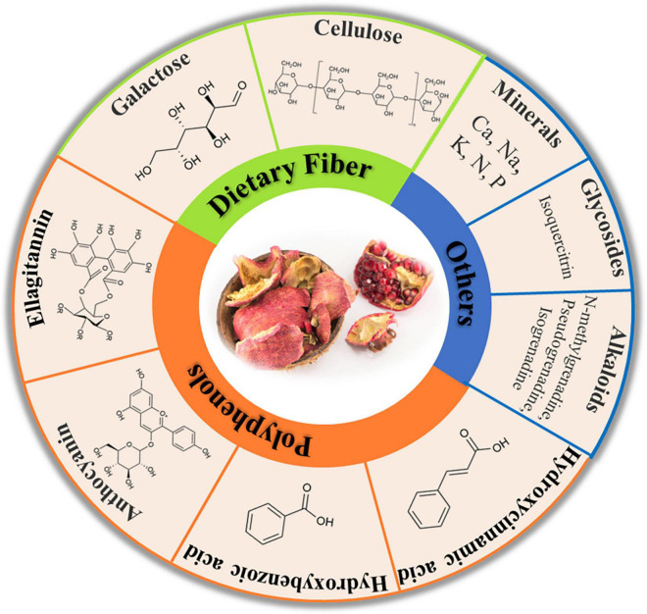

*Figure 1: Some bioactive compounds present in PPs* (Mo, Ma and Gao)

Their phenolic profile consists mainly of tannins, flavonoids, and phenolic acids and these polyphenols consist of up to 50% of the weight composition of PPs (depending on the extraction method and testing method used) (Mo, Ma and Gao). This high polyphenolic content makes PPs a promising green alternative to traditional chelating agents for treating heavy metal contaminated water – since PPs have been known to effectively interact with, and neutralize, heavy metal ions such as copper (Rashed and Tayh). Hence, the present study aims to explore the mechanism of the interaction between the polyphenols of the PP and the copper ions as well as to optimize it by varying variables such as the PPP mass, extraction solvent, copper ion concentration, metal ion-ligand ratios, and pH.

# 3 Research Question

This led me to formulate the research question – **How do phenolic acid derivatives obtained from pomegranate peel interact with Copper (II) ions?**

The study explores the optimal mass of PPP, extraction solvent, copper ion concentration, metal-ligand ratio, and pH environment which yields the highest EI. To understand the interactions that take place between the phenolic derivatives and the copper (II) ions, we need to look into the individual components first.

# 4 Background Information

## 4.1 Copper

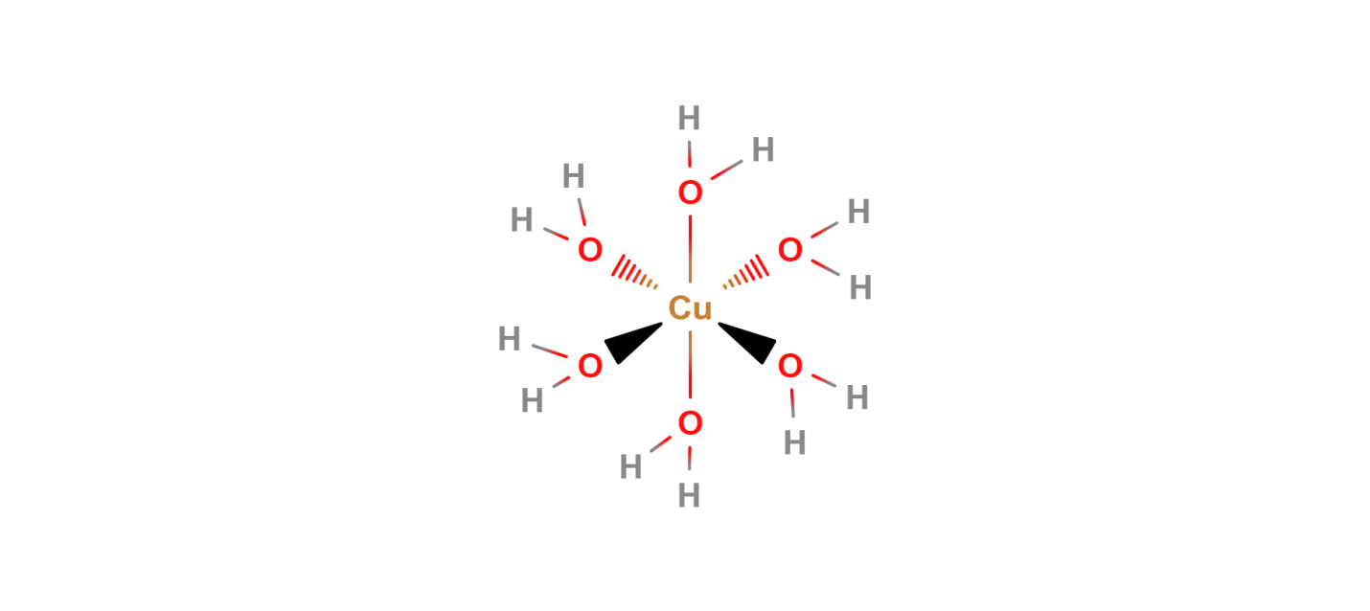In the center of the interaction is the metal ion, copper, which is the third-most used metal with applications in industries such as wiring and construction (U.S. Congress, Office of Technology Assessment). Although essential for bone and cardiovascular health(Araya, Olivares and Pizarro), copper has been linked to several adverse effects in the body(Manne, Kumaradoss and Iska). It is mainly introduced into the body through water (Manne, Kumaradoss and Iska) – which is the motive behind this research in reducing copper content in water.

*Figure 2: The octahedral structure of the complex [Cu(H2O)]6 ]2+ (Hexaaquacopper(II))* (MolView)

Located in the d-block of the periodic table, copper is a transition metal with a unique electronic configuration of [Ar]4s13d10. This configuration is taken by the copper atom as it is more stable having an incomplete s-orbital than an incompletely filled d-orbital(Brown and Ford). Copper can exist in two oxidation states including as Cu+, however, it is most commonly found as Cu2+ with the loss of one electron from the outermost 4s-subshell and the loss of another electron from the 3d-subshell. In its more stable +2 oxidation state, copper ions have a maximum of six binding sites as shown in Figure 2. These binding sites allow molecules called ligands to form coordinate bonds with the copper ion, forming copper complexes and thus remediating heavy-metal contaminated water.

## 4.2 Ligands and Denticity

As briefly outlined in the previous section, ligands are molecules or ions that bind to a central metal ion to form a substance called a complex – the polyphenolic derivates from PP being the ligands used in this study. Ligands have one or more ions with a pair of electrons that can be used to form one or more dative bonds with the metal ion. They act as a Lewis base through electron pair donation, while the metal ion/ion acts as a Lewis acid via accepting them.

Ligands are classified by two factors, their denticity and strength. Denticity is a characteristic of a ligand’s binding site(s). For example, as seen in Figure 3, when a polydentate ligand approaches a metal ion, multiple dative bonds are formed between the metal ion and the binding sites of the ligand. This process is a special type of complexation called chelation.

## Screenshot 2024-02-06 011810.png4.3 Chelation

Having origins from the Greek word for ‘claw,’ (Flora and Pachauri) chelation differs from complexation by the denticity of the participating ligands. Monodentate ligands like water offer only one binding site, leading to complexation as seen in Figure 2. Polydentate ligands (also known as chelating agents) meanwhile interact with the central metal ion through multiple binding sites (such as inFigure 3); thus, leading to chelation. Chelating agents wrap around the metal ion, forming ring-like/cage-like structures called chelate complexes or chelates which boost the stability of the complex - this is referred to as the chelate effect(Lancashire). Chelation is the primary type of interaction that takes place between the copper (II) ions and the phenolic derivates from the PP as will be detailed in the following sections.

*Figure 3: Pictorial representation of complexation (top) and chelation (bottom)* (Flora and Pachauri)

Another factor that is used to categorize ligands is their strength (as mentioned in the Section 4.2), which will be detailed upon in the following section.

## 4.4 Ligand Strength and Colored Complexes

When the ligands interact with the metal ion/ion, the degeneracy (energy-level) of the metal ion's d-orbital is lifted, resulting in the formation of t2g and eg sub-levels. The energy difference between these sub-levels is influenced by both the metal ion’s and ligand’s properties. This determines the wavelength of light which is absorbed by the complex, thus resulting in the complementary color being seen. This process is visually detailed in Flowchart 1.

The color of a metal complex is determined by the extent to which the d-orbitals of the metal ion is split. The spectrochemical/ligand strength series (Figure 4) arranges some commonly studied/used ligands in the increasing order of their ability to split the energy levels of the metal ions (Tsuchida).

|  |
| --- |
| **I−< Br−< S2−< Cl−< F− < OH−< H2O < SCN−< NH3< CN−< CO** |
| *Figure 4: Spectrochemical Series* (Tsuchida) |

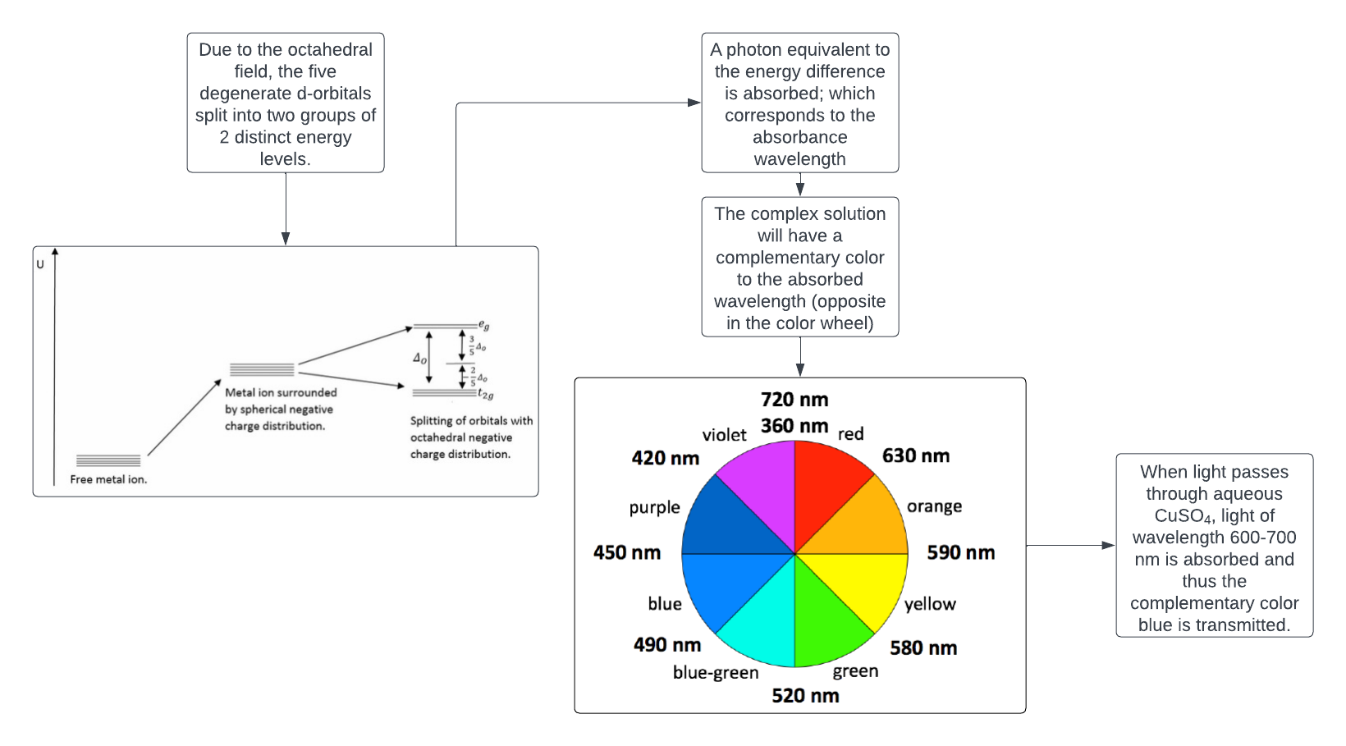

*Flowchart 1: The process of d-d splitting by the octahedral field and the formation of colored complexes* (Lucidchart)(LibreTexts)

Flowchart 1

*: The process of d-d splitting by the octahedral field and the formation of colored coordinate complexes* (Lucidchart)

Given that the function of the polyphenolic derivates from PP as chelators is now established, it is reasonable to delve deeper into the specificities of these chelate-metal ion interactions – first, however, this requires an understanding of the polyphenolic profile of PPs.

## 4.5 Polyphenols present in PP

Phenolic compounds, such as polyphenols, are a major group of compounds which have been recognized for their contribution to our health(Belščak-Cvitanović, Durgo and Huđek). They are characterized by the presence of multiple phenol groups in the molecule, making them effective natural metal chelating agents as identified in literature(Belščak-Cvitanović, Durgo and Huđek). There are many polyphenolic compounds present in PPs, from tannins and flavonoids to various phenolic acids (Mo, Ma and Gao); the primary ones identified being the phenolic acids GA and EA (which constitute approximately 60-80% of the total phenolic content depending on the extraction conditions) (Figure 6(Kupnik, Leitgeb and Primožic)). Other polyphenols present in large quantities in PPP extracts include flavonoids such as catechin and epicatechin (Figure 6(Kupnik, Leitgeb and Primožic)).

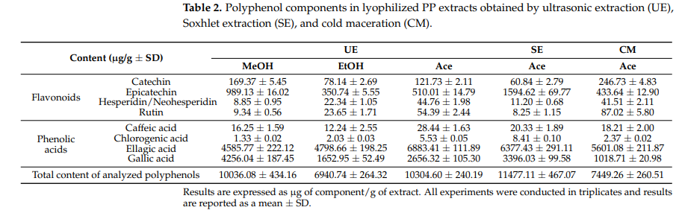

*Figure 5: Chemical constituents of PPP extracts in varying extraction conditions* (Kupnik, Leitgeb and Primožic)

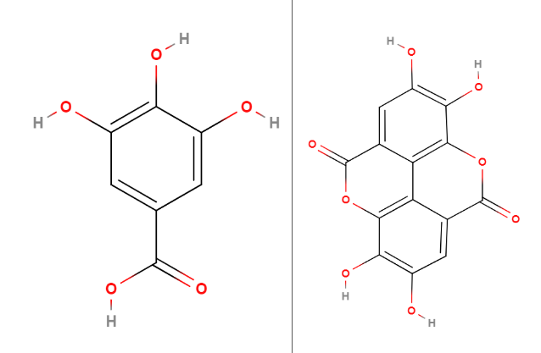

*Figure 6: Molecular structures of two major polyphenolic constituents of PP, GA and EA (right to left)* (MolView)

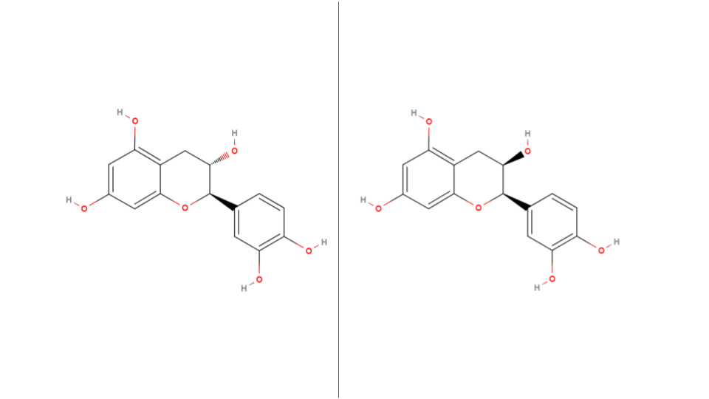

*Figure 7: Molecular structures of two minor polyphenolic constituents of PP, catechin and epicatechin (right to left)* (MolView)

The multiple hydroxyl and carboxyl groups on the GA and the hydroxyl groups on the EA can donate electrons to the Cu2+ ions. GA can only undergo complexation as the oxygen ion in central hydroxyl group cannot form multiple dative bonds – thus GA should be considered as a bidentate ligand which can only bind with a singular copper ion. EA, on the other hand, can undergo chelation with copper as it has four hydroxyl groups. This is shown in Figure 9. Figure 10 shows alternative complex structures that may also form; it should be noted that, in Figure 10, the Cu-EA complex has a possibility to form a long-chain complex since the copper ions in the periphery of the EA molecule could coordinate with neighboring EA or even GA or other ligands. Moreover, these long-chain complexes should have greater stability (Section 4.3), 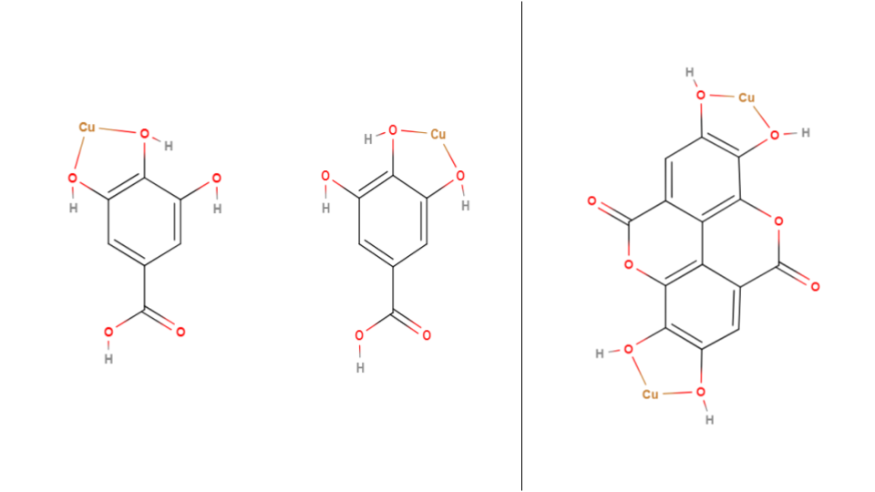increasing the chances for their formation (although there is the issue of steric hinderance).

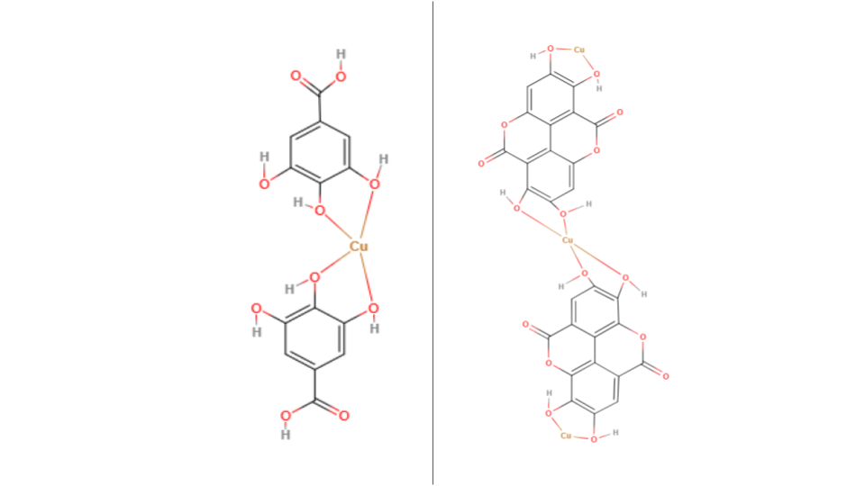

*Figure 8: Possible complex structures for GA (left and center) and EA (right).*

*Figure 9: Possible Cu-GA complex (left) and Cu-EA complex (right).*

These two ligands, along with other polyphenols present in PPP extract (Figure 6 (Kupnik, Leitgeb and Primožic)), contribute to the PP’s ability to treat heavy metal contaminated water. This prompted me to explore PPs further and their role in the process of water purification.

Now, the thermodynamic properties of the interaction between the ligands and copper will be elaborated upon since they determine the driving force for probing the extent of metal-ligand interaction.

## 4.6 Thermodynamics in Chelation

In an aqueous medium (through which most copper is ingested by the body (Manne, Kumaradoss and Iska)), copper (II) ions exist as the complex Hexaaquacopper (II) (Figure 2) (Clark). This is due to the sum of the hydration enthalpies of copper and sulfate ions (-2100 (Chieh) and -1099 (Barret) kJmol-1 respectively) being higher in magnitude than the lattice enthalpy of CuSO4 (which will be used to prepare the copper solution) (3066 kJmol-1 (Yoder and Flora)), thus resulting in the solvation of the copper ions by water molecules and the formation of Cu-hydrated complexes like the aforementioned one.

When a chelating agent like GA or EA approaches the hydrated copper complex, an associative substitution/ligand exchange mechanism comes into play as shown in Figure 11 (MolView). This is a spontaneous mechanism as the reaction enthalpy is negative and there is an increase in entropy (due to the loss of multiple aqua ligands in the Hexaaquacopper (II) complex), which results in an overall negative Gibbs free energy value (as shown by Equation 1). Moreover, the chelate is more stable than the hydrated complex due to the previously mentioned chelate effect.

[1]

|  |
| --- |
| **ΔG** = Change in Gibbs free energy | **ΔH** = Enthalpy | **T** = Temperature | **ΔS** = Change in entrophy |

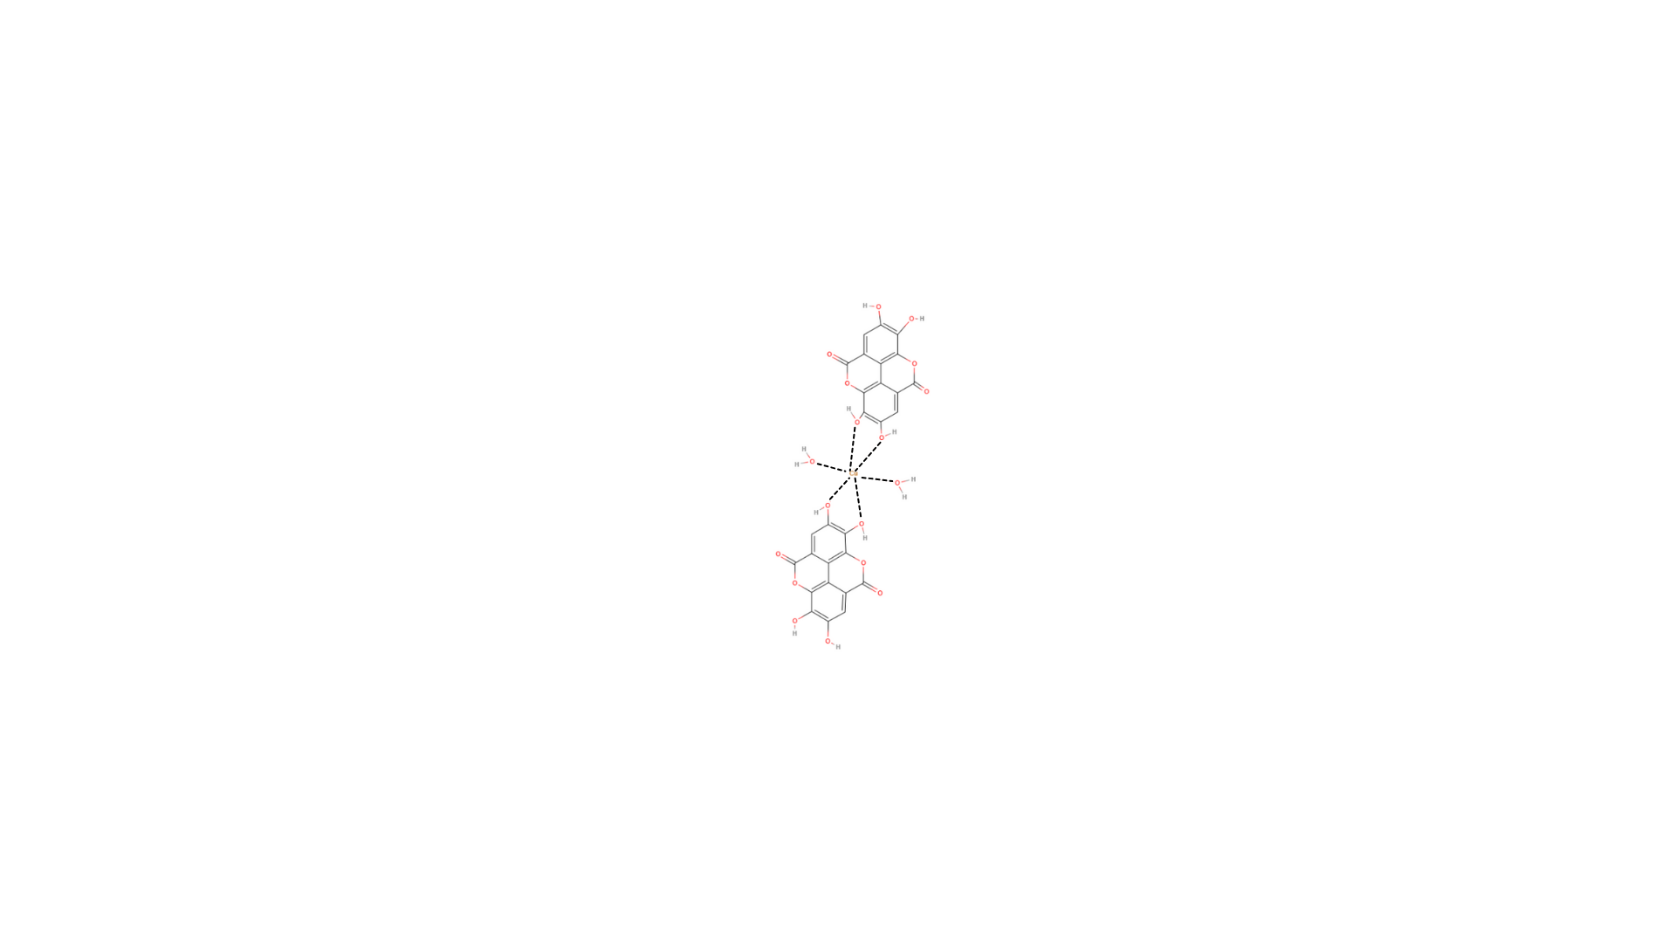

*Figure 10: The transient state in the associative substitution mechanism for when the EA approaches and begins to interact with the copper ion as the aqua ligands disassociate* (MolView)

Having understood the modes of interaction, we can now comprehensively investigate the variables of the study in order to optimize and predict the results of the experimentation.

## 4.7 Effect of Solvent

Before the complexation and chelation processes can begin, ligands must first be extracted from the PPP. The solvent with the highest degree of interaction with the ligands – which will allow it to overcome the intermolecular forces keeping the ligands together (Burke) – will have the highest extraction efficiency and thus the most optimal EI values. The major factors affecting the interaction are the solvent’s polarity and intermolecular forces (Burke).

Firstly, the polarity of the solvent determines its ability to interact with the polar groups of GA and EA, namely the carboxylic acid group of GA and the hydroxyl groups of both molecules. Polarity may play a lesser role in the solvation of EA than GA, which can be attributed to EA’s much higher molecular mass than GA (PubChem) and due to EA containing several non-polar arene groups that predominantly interact with other non-polar molecules (Burke).

A lower proportion of the overall mass is accounted for by the polar groups in EA than GA (as both have 4 hydroxyl groups) while the larger structure of EA hinders polar interactions through steric hinderance, and thus - although polarity plays a vital role in the solubility of these compounds in a solvent – the higher molecular mass of EA would result in lower extraction yields for it than GA in a polar solvent.

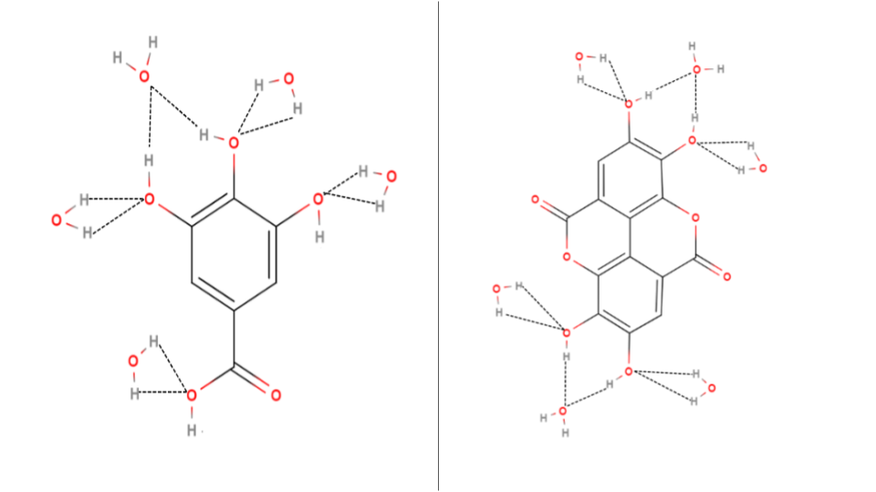

*Figure 11: Hydrated cluster of GA (left) and EA (right). Water molecules form hydrogen bonds (dash lines) with the hydroxyl groups in each ligand, dissolving it* (MolView)*.*

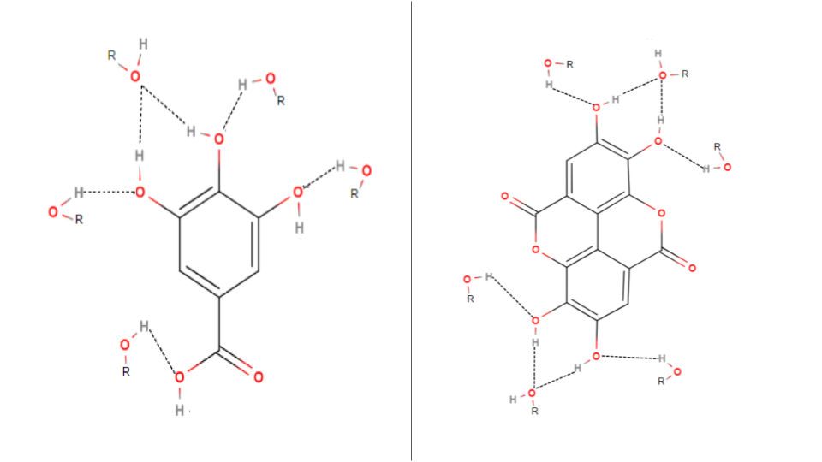

*Figure 12: Generic solvation cluster of GA (left) and EA (right). The hydroxyl group of the alcohol molecules (ROH) form hydrogen bonds (dash lines) with the hydroxyl groups in each ligand, dissolving it* (MolView)*.*

Secondly, although not as strong as the hydrogen bonding present in the polar interactions in GA and EA, the intermolecular van der Waals forces also hold the potential to impact a solvent’s solvation capabilities. A greater van der Waals interaction between the solvent and solute molecules translates to higher solvation efficiencies – especially in the case of EA which has large aromatic ring groups which can interact extensively with large, non-polar molecules through the van der Waals forces due to the higher surface area and electron density that the aromatic groups in EA have over smaller arenes such as GA.

Literature data validates this - GA(Daneshfar, Ghaziaskar and Homayoun) and EA(Bala, Bhardwaj and Hariharan) are more soluble in methanol and ethanol than water (with ethanol being in the middle for both acids). Methanol, with its moderate polarity and surface area, balances both solubility factors and thus has the most optimal results. The superior performance of ethanol relative to water suggests that van der Waals forces play a more significant role in dissolving the ligands than polarity does since the effect of water’s higher polarity is offset by ethanol’s higher van der Waals forces in terms of their solvation performance. This finding will be useful for the framing of the first hypothesis.

The selection of these solvents was based upon their high availability and low-cost, which connects with the sustainable focus of this study.

## 4.8 Effect of pH Environment

Another factor to optimize is the pH of the complexation environment, which can play a significant role in the complexation efficiency of the PPP extract due to pKa values, which govern the deprotonation behavior of the molecules which can strongly influence the extent to which complexation occurs.

In alkaline conditions, the GA will deprotonate, owing to the presence of a carboxylic group as well as three hydroxyl groups (Figure 7). Its first pKa (Table 1) corresponds to the carboxylic group which deprotonates first (Huguenin, Hamady and Bourson). The following pKa values in Table 1 correspond to the hydroxyl groups (Huguenin, Hamady and Bourson).

As the alkalinity of the complexing solution increases from slightly acidic to highly basic, GA will undergo a greater degree of deprotonation, ultimately forming the gallate anion shown in Figure 14. This gradual ionization enhances its ability to act as a ligand since the ions have a greater denticity – specifically through the deprotonated carboxyl and hydroxyl groups – hence increasing the EI.

|  |  |
| --- | --- |
| **pKa for GA** | **pKa for EA** |
| 4.4 ± 0.1 | 6.3 |
| 8.7 ± 0.1 |
| 10.4 ± 0.1 | 11.2 |
| 11.4 ± 0.1 |
| *Table 1: pKa values for GA* (Huguenin, Hamady and Bourson) *and EA* (Muñoz-Muñoz, Gracia-Molina and Garcia-Molina)*.* | |

EA is peculiar in that it only has two pKa values (Table 1) for four hydroxyl groups (Figure 7). This arises from the fact that EA is a symmetrical dimer, functioning as a dilactone between two GA molecules, with their benzene rings connected by a carbon-carbon bond (Muñoz-Muñoz, Gracia-Molina and Garcia-Molina).

By looking at Table 1, we can determine that EA will have a similar situation as GA since, in neutral and highly alkaline conditions, the pH of the complexing solution would exceed its both its pKa values, thus all the hydroxyl groups present in the molecule will deprotonate and result in the formation of the ellagate anion (Figure 14), leading to greater complexation between EA and copper ions.

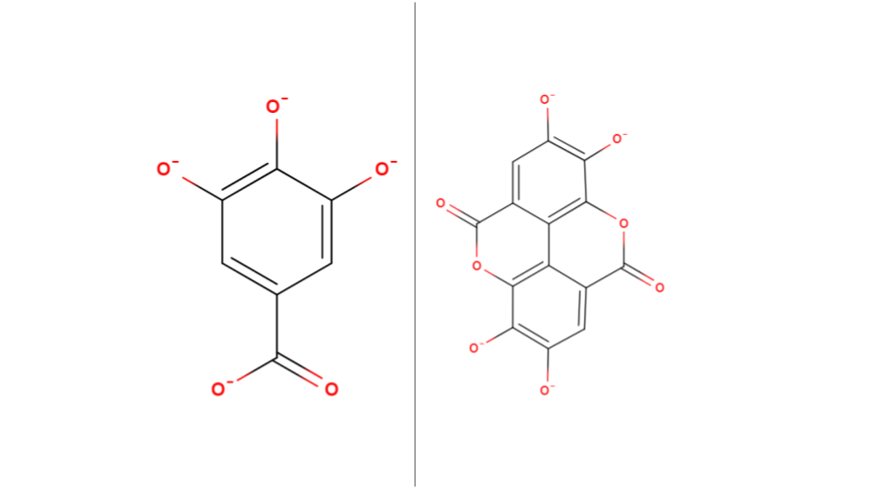

*Figure 13: Ionic structures of gallate (left) and ellagate (right) anions. Negative charges marked on the oxygen ions of the deprotonated carboxyl (for GA) and hydroxyl groups.* (MolView)

However, the presence of excess hydroxide ions (OH-) in an alkaline environment could compete with the anions for binding with the copper ions. This competition may lead to the formation of insoluble copper hydroxide precipitates, which would decrease the availability of free copper ions to form complexes with the ligands from the PPP extract, thus potentially affecting the EI.

*Equation 2: Chemical equation for the possible formation of copper (II) hydroxide.*

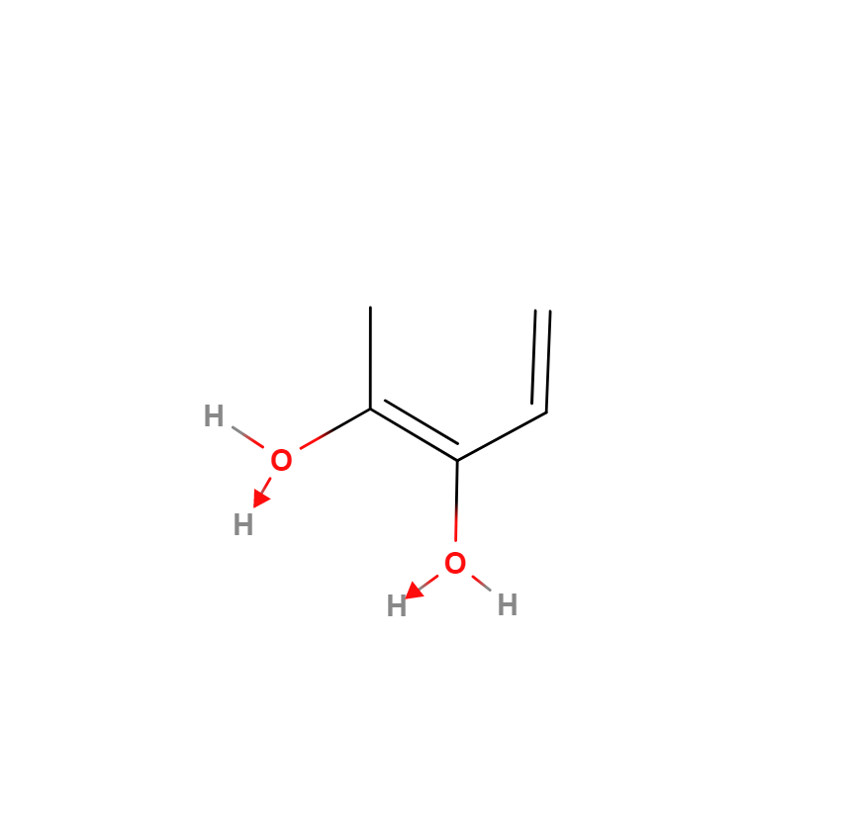The opposite effect is expected in acidic conditions. The increased protonation of the oxygen ion in the carboxyl (for GA) and hydroxyl groups (due to the formation of a dative bond as shown in Figure 15) present in GA and EA should negatively affect complex formation since the oxygen ions’ lone pairs are used for the protonation of the hydroxylgroup, resulting in the loss of available binding sites in the ligands. Moreover, the excess H+ ions present in the acidic medium will compete with the already weakened ligands for the copper ions, further negatively affecting the EI.

*Figure 14: Protonation of the hydroxyl group in low pH environments* (MolView)*.*

## 4.9 Determination of Extent of Interaction

The most suitable method to determine the efficacy of the experiments is UV-Visible spectroscopy as it is a simple analytical technique which allows us to deduce the characteristics of metal-ligand complexes by their photon absorption at varying wavelengths(Edinburgh Instruments). This method hinges on the Beer-Lambert Law, which correlates the absorbance value provided by the spectrophotometer with the concentration of metal ions in the solution:

A = [3]

|  |
| --- |
| **A** = Absorbance value | **ε** = Molar absorption | **c** = Concentration | **l** = Path Length |

The spectrophotometer displays the amount of light absorbed by the solution in the cuvette. This absorbance value is inversely proportional to the metal-ligand complex concentration in the solution. Hence, in order to deduce the concentration of the remaining Cu2+ions in the solution, we use a curve that graphs absorbance against concentration.

The λmax value is the wavelength at which the Cu2+ion exhibits the highest absorbance. After chelation has occurred, we record the absorbance at the λmax wavelength to determine the complexing efficiency:

EI (%) = [4]

|  |
| --- |
| **EI** = Extent of interaction | **Am** = Absorbance of metal ion | **Ac** = Absorbance of complex solution |

# 5 Hypothesis

## 5.1 Hypothesis 1 – Solvent Performance

As elaborated upon in Section 4.7, literature data suggests that methanol would be the most performant solvent compared to ethanol and water respectively as it strikes a balance between polarity and van Der Waals interactions (relative to ethanol and water), thus leading to higher complexation rates.

The diluted counterparts of methanol and ethanol should see a lower EI than the pure solutions since it has been established in Section 4.7that the water solvent is the least performant, thus, diluting the solvents should diminish the advantage that they have in extracting non-polar ligands, hence negatively impacting their ligand extraction capability.

|  |
| --- |
| **Methanol > Ethanol > Water > 50% Methanol > 50% Ethanol** |

## 5.2 Hypothesis 2 – Effect of PPP Mass Used

As the mass of the PPP used for extraction increases, the number of interacting species which could be extracted increases as well. As such, there should be a higher extraction yield and thus a higher ligand:Cu2+ ratio, leading to higher EI.

|  |
| --- |
| **0.05 > 0.025 > 0.01g** |

## 5.3 Hypothesis 3 – Effect of Metal Ion concentration

A higher concentration of the Cu2+ ion will result in more complexation as there will be a greater number of cations per unit volume, thus there will be a greater chance of a successful collision (and complexation) of the ligands and the copper ions.

|  |
| --- |
| **0.075 > 0.05 > 0.025 moldm-3** |

## 5.4 Hypothesis 4 – Effect of Metal Ligand Voluminal Ratio

The most optimal metal-to-ligand ratio should be around 1:2. This ratio was approximated using information from Section 4.5 as well as from Figures 9 and 10 which established possible Cu-ligand complex structures. The above ratio should strike a balance between the total number of empty orbitals present in all the copper ions as well as the total number of binding sites in the ligands. This is followed by metal:ligand ratios with a higher proportion of ligands due to the higher availability of ligands and then followed by the metal:ligand ratios with a higher proportion of copper ions due to the lower availability of ligands.

|  |
| --- |
| **10:20 > 10:30 > 20:30 > 10:10 > 30:20 > 20:10 > 30:10** |

## 5.5 Hypothesis 5 – Effect of pH Environment

The EI of the PPP extract solution with copper is expected to be lower in acidic conditions as discussed in Section 4.8. Moreover, it is expected that pH 7 will have a similar EI value as its non-pH mediated part since both should have similar pH conditions during complexation.

|  |
| --- |
| **pH 2 < pH 5 < pH 7 ≈ No pH mediation** |

# 6 Preliminary Investigations

Preliminary studies were conducted in order to set the fixed variables and to determine a suitable range for the independent variables. The λmax for copper (II) sulfate solution was determined and an absorbance/concentration graph was plotted.

**6.4 UV-Vis Spectroscopy**

***6.4.1 Lambda Max Determination***

The determination of the λmax value is essential for this study as it will be used to determine the EI. The lambda scan graph for 0.05 moldm-3 CuSO4.xH2O solution (Graph 1) has a peak at 775 nm which was set as the λmax value.

*Graph 1: Graph of absorbance vs. wavelength for CuSO4(aq).*

***6.4.2 Standard Calibration Curve***

A standard/calibration curve is used to plot the linear relationship between the absorbance and concentration of a metal complex solution as according to Beer-Lambert’s Law. The λmax wavelength is used to measure the absorbance for each concentration. The high R2 value (0.977) proves the precision and reliability of the spectrophotometer used.

*Graph 2: Standard curve of CuSO4(aq) at λmax (775 nm)*

## 6.1 Selection of Extraction Method

Various extraction methods were tested – shaking, heating, and heated magnetic stirring – in order to determine which one would yield the highest degree of interaction. The heating mantle offered the highest complexation values and was thus chosen as the default extraction method for the study.

## 6.2 Selection of Boiling Duration

A range of boiling durations were chosen – 5, 10, and 15 minutes– in order to determine the extent to which thermal degradation and solvent solubility affects the metal interaction efficiency of the solutions. Finally, 5 minutes was chosen since the alcohol solutions experienced high levels of evaporation and were boiling off in extended boiling durations.

## 6.3 Selection of Solvents

Water, ethanol, methanol, and their binary equivalents were considered for the study as reasoned in Section 4.7.

## 6.4 Selection of PPP Mass

0.100, 0.050, 0.025 and 0.010 grams of PPP were used in the preliminary tests to determine the extent of extraction of ligands. 0.100g was not used for the actual study due to the complexed solutions being too turbid to make reliable spectrophotometric measurements.

# 7 Variables

## 7.1 Independent

|  |  |
| --- | --- |
| **Solvents** | Water, Ethanol, Methanol, 50% Ethanol, 50% Methanol |
| **Mass of PPP (g)** | 0.010, 0.025, 0.050 |
| **Concentration of Cu2+ (moldm-3)** | 0.025, 0.050, 0.075 |
| **Solution:Cu2+ Voluminal Ratio (cm3)** | 10:20, 10:30, 20:30, 10:10, 30:20, 20:10, 30:10 |
| **pH for complex solutions** | 2, 5, 7 |
| *Table 2: Independent variables of the study.* | |

## 7.2 Dependent

|  |
| --- |
| **Absorbance value for each solution at λmax** |
| **Calculated value of EI from the absorbance (using Equation 4)** |
| *Table 3: Dependent variables of the study.* |

# 8 Preparation of Reagents

## 8.1 Preparation of ligand solutions

**Step 1:** The 0.1g of PPP (as measured by the electronic top pan balance) is transferred to a beaker using a spatula.

**Step 2:** 50cm3 of solvent is added to the beaker (as measured by a 100cm3 measuring cylinder).

**Step 3:** The beaker is then placed in the heating mantle for the required duration at 100oC.

**Step 4:** After a cooldown period of one minute, the extraction solution is filtered to remove the PPP and 20cm3 of the solution is then transferred to a flask using a pipette.

## 8.2 Preparation of CuSO4 standards of varying concentrations

|  |  |
| --- | --- |
| **CuSO4 Concentration in (moldm-3)** | **Mass required for 100cm3 of standard (g)** |
| 0.025 | 0.624 ± 0.001 |
| 0.050 | 1.248 ± 0.001 |
| 0.075 | 1.872 ± 0.001 |
| The required mass of CuSO4 (Mr = 249.609) for each concentration was measured using an electronic top pan balance and diluted to 100.0 ± 0.5cm3 using a standard flask. Before use, the standard flasks were shaken thoroughly to ensure uniform composition. | |

## 8.3 Preparation of complex solutions

**Step 1:** The required volume of the ligand solution is transferred to a flask using a pipette.

**Step 2:** The required volume and concentration of the copper standard is added to the flask using a pipette.

**Step 3:** The flask is then left to equilibrate in the rotary shaker for 3 hours.

**Step 4:** Then a sample is taken from the complexed solution in the flask for further analysis.

## 8.4 Preparation of pH 2 buffer

### 8.4.1 Reagent 1 Preparation (0.20 moldm-3 Hydrochloric Acid)

**Step 1:** 1cm3 of Hydrochloric Acid solution was measured using a pipette then added to 50cm3 of distilled water in a measuring cylinder.

**Step 2:** The solution was transferred to a 100cm3 standard flask and the standard flask was filled with distilled water until the 100cm3 mark.

### 8.4.2 Reagent 2 Preparation (0.20 moldm-3 Potassium Chloride)

**Step 1:** 1.490g of Potassium Chloride was weighed on a digital scale.

**Step 2:** The salt was then transferred to a beaker containing 50cm3 distilled water and the solution was stirred thoroughly.

**Step 3:** The solution was transferred to a 100cm3 standard flask and the standard flask was filled with distilled water until the 100cm3 mark.

### 8.4.3 Buffer Preparation

**Step 1:** Using a measuring cylinder, 13.0±0.5 cm3of Reagent 1 was measured and transferred to a 250cm3 beaker.

**Step 2:** Using a measuring cylinder, 50±0.5 cm3of Reagent 2 was measured and transferred to the same 250cm3 beaker containing Reagent 1.

**Step 3:** Using a measuring cylinder, 137±0.5 cm3 of distilled water was measured and transferred to the aforementioned 250cm3 beaker to obtain pH 2 buffer solution.

## 8.5 Preparation of pH 5 buffer

### 8.5.1 Reagent 1 Preparation (0.10 moldm-3 Glacial Acetic Acid)

**Step 1:** 0.600g of Glacial Acetic Acid was weighed on a digital scale.

**Step 2:** The salt was then transferred to a beaker containing 50cm3 distilled water and the solution was stirred thoroughly.

**Step 3:** The solution was transferred to a 100cm3 standard flask and the standard flask was filled with distilled water until the 100cm3 mark.

### 8.5.2 Reagent 2 Preparation (0.10 moldm-3 Sodium Acetate Trihydrate)

**Step 1:** 1.362g of Sodium Acetate Trihydrate was weighed on a digital scale.

**Step 2:** The salt was then transferred to a beaker containing 50cm3 distilled water and the solution was stirred thoroughly.

**Step 3:** The solution was transferred to a 100cm3 standard flask and the standard flask was filled with distilled water until the 100cm3 mark.

### 8.5.3 Buffer Preparation

**Step 1:** Using a measuring cylinder, 59.0±0.5 cm3of Reagent 1 was measured and transferred to a 250cm3 beaker.

**Step 2:** Using a measuring cylinder, 141±0.5 cm3of Reagent 2 was measured and transferred to the same 250cm3 beaker containing Reagent 1 to obtain pH 5 buffer solution.

## 8.6 Preparation of pH 7 buffer

**Step 1:** Using a measuring cylinder, 100±0.5 cm3 of distilled water was measured and transferred to a 100cm3 beaker.

**Step 2:** The contents of a pH 7 buffer preparation capsule was added to the beaker and the solution was stirred thoroughly to obtain pH 7 buffer solution.

## 8.7 Preparation of complex solutions with buffer

**Step 1:** The required volume of the ligand solution is transferred to a flask using a pipette.

**Step 2:** 5cm3 of the required buffer is added to the ligand solution using a pipette.

**Step 3:** The required volume and concentration of the copper standard is added to the flask using a pipette.

**Step 4:** The flask is then left to equilibrate in the rotary shaker for 3 hours.

**Step 5:** Then a sample is taken from the complexed solution in the flask for further analysis.

# 9 Data Collection

The calculations for the uncertainties of the varying concentrations of metal ion solutions are given in the Appendix (Section 16.1.1).

## 9.1 Qualitative Data

|  |  |
| --- | --- |
| 9.1.1 Complex Solutions for Varying Solvents | |
| **Water** | Olive green, medium turbidity, slight brown precipitates |
| **Ethanol** | Olive green, high turbidity |
| **Methanol** | Olive green, high turbidity |
| **50% Ethanol** | Olive green, light blue precipitates |
| **50% Methanol** | Pale light blue, light blue precipitates |
| *Table 4: Qualitative data for the complexed solutions for varying solvents.* | |

|  |  |  |  |
| --- | --- | --- | --- |
| 9.1.2 Complex Solutions at Varying PPP Mass (± 0.001) (g) | | | |
| **Solvent/Mass** | **0.010** | **0.025** | **0.050** |
| **Water** | Olive green, slight turbidity, brown precipitates | Olive green, medium turbidity | Olive green, medium turbidity, slight brown precipitates |
| **Ethanol** | Olive green, slight turbidity, brown precipitates | Olive green, medium turbidity | Olive green, high turbidity |
| **Methanol** | Pale light blue, medium turbidity, brown precipitates | Olive green, high turbidity | Olive green, high turbidity |
| *Table 5:* *Qualitative data for the complexed solutions for varying PPP mass (g).* | | | |

|  |  |  |  |
| --- | --- | --- | --- |
| 9.1.3 Complex Solutions at Varying Copper Concentrations (moldm-3) | | | |
| **Solvent/Concentration** | **0.025 ± 1.65×10-4** | **0.050 ± 1.45×10-4** | **0.075 ± 1.38×10-4** |
| **Water** | Pale olive green, low turbidity | Olive green, medium turbidity, slight brown precipitates | Olive green, high turbidity, brown precipitates |
| **Ethanol** | Pale olive green, medium turbidity | Olive green, high turbidity | Olive green, extreme turbidity, brown precipitates |
| **Methanol** | Pale olive green, medium turbidity | Olive green, high turbidity | Olive green, extreme turbidity, brown precipitates |
| *Table 6: Qualitative data for the complexed solutions for varying copper concentration (moldm-3).* | | | |

|  |  |  |
| --- | --- | --- |
| 9.1.4 Complex Solutions for Varying Cu2+:Ligand Voluminal Ratios (cm3) | | |
| **Water** | **10:10** | Olive green, slight turbidity, slight brown precipitates |
| **10:20** | Pale teal |
| **10:30** | Olive green, medium turbidity |
| **20:10** | Pale light blue, brown precipitates |
| **20:30** | Pale olive green, slight turbidity |
| **30:10** | Olive green, slight turbidity, high amount of brown precipitates |
| **30:20** | Olive green, slight turbidity, slight brown precipitation |
| **Methanol** | **10:10** | Golden yellow, medium turbidity, slight brown precipitates |
| **10:20** | Olive green |
| **10:30** | Olive green, slight turbidity |
| **20:10** | Olive green, brown precipitates |
| **20:30** | Pale olive green, slight turbidity |
| **30:10** | Teal, high amount of brown precipitates |
| **30:20** | Olive green, slight turbidity, slight brown precipitation |
| *Table 7: Qualitative data for the complexed solutions for varying voluminal ratios (cm3).* | | |

|  |  |  |  |  |
| --- | --- | --- | --- | --- |
| 9.1.5 Complex Solutions at Varying pH and PPP Mass (± 0.001) (g) (0.075 moldm-3 Cu2+) | | | | |
| **pH** | **Solvent/Mass** | **0.025** | **0.050** | **0.075** |
| **2** | **Water** | Olive green, medium turbidity | Olive green, high turbidity | Olive green, extreme turbidity |
| **50% Ethanol** | Olive green, slight turbidity | Olive green, high turbidity | Olive green, extreme turbidity |
| **5** | **Water** | Olive green, slight turbidity | Olive green, slight turbidity | Olive green, slight turbidity |
| **50% Ethanol** | Olive green, slight turbidity | Olive green | Olive green |
| **7** | **Water** | Olive green | Pale teal | Pale teal |
| **50% Ethanol** | Olive green | Pale teal | Pale teal |
| *Table 8: Qualitative data for the complexed solutions for varying pH and PPP mass (g) at 0.075 moldm-3 copper concentration* | | | | |

## 9.2 Quantitative Data – Absorbance Values

|  |  |
| --- | --- |
| 9.2.1 Complex Solutions for Varying Solvents | |
| **Water** | 0.123 |
| **Ethanol** | 0.117 |
| **Methanol** | 0.062 |
| **50% Ethanol** | 0.233 |
| **50% Methanol** | 0.210 |
| *Table 10: Quantitative data for the complexed solutions for varying solvents.* | |

|  |  |  |  |
| --- | --- | --- | --- |
| 9.2.2 Complex Solutions at Varying PPP Mass (± 0.001) (g) | | | |
| **Solvent/Mass** | **0.010** | **0.025** | **0.050** |
| **Water** | 0.177 | 0.135 | 0.123 |
| **Ethanol** | 0.250 | 0.168 | 0.117 |
| **Methanol** | 0.185 | 0.107 | 0.062 |
| *Table 11:* *Quantitative data for the complexed solutions for varying PPP mass (g).* | | | |

|  |  |  |  |
| --- | --- | --- | --- |
| 9.2.3 Complex Solutions at Varying Copper Concentrations (moldm-3) | | | |
| **Solvent/Concentration** | **0.025 ± 1.65×10-4** | **0.050 ± 1.45×10-4** | **0.075 ± 1.38×10-4** |
| **Water** | 0.116 | 0.123 | 0.182 |
| **Ethanol** | 0.119 | 0.117 | 0.186 |
| **Methanol** | 0.070 | 0.062 | 0.135 |
| *Table 12: Quantitative data for the complexed solutions for varying copper concentration (moldm-3).* | | | |

|  |  |  |  |  |  |  |  |  |  |  |  |  |  |  |  |  |  |  |  |  |  |  |  |  |  |  |  |  |  |  |  |  |  |  |  |  |  |  |  |  |
| --- | --- | --- | --- | --- | --- | --- | --- | --- | --- | --- | --- | --- | --- | --- | --- | --- | --- | --- | --- | --- | --- | --- | --- | --- | --- | --- | --- | --- | --- | --- | --- | --- | --- | --- | --- | --- | --- | --- | --- | --- |
| |  |  |  | | --- | --- | --- | | 9.2.4 Complex Solutions for Varying Cu2+:Ligand Voluminal Ratios (cm3) | | | | **Water** | **10:10** | 0.208 | | **10:20** | 0.122 | | **10:30** | 0.213 | | **20:10** | 0.202 | | **20:30** | 0.188 | | **30:10** | 0.211 | | **30:20** | 0.208 | | **Methanol** | **10:10** | 0.177 | | **10:20** | 0.061 | | **10:30** | 0.180 | | **20:10** | 0.188 | | **20:30** | 0.158 | | **30:10** | 0.183 | | **30:20** | 0.183 | | *Table 13: Quantitative data for the complexed solutions for varying voluminal ratios (cm3).* | | | | | | | |
| 9.2.6 Complex Solutions at Varying pH and PPP Mass (± 0.001) (g) (0.075 moldm-3 Cu2+) | | | | |
| **pH** | **Solvent/Mass** | **0.025** | **0.050** | **0.075** |
| **2** | **Water** | 0.202 | 0.183 | 0.166 |
| **50% Ethanol** | 0.269 | 0.277 | 0.277 |
| **5** | **Water** | 0.177 | 0.166 | 0.139 |
| **50% Ethanol** | 0.263 | 0.263 | 0.258 |
| **7** | **Water** | 0.155 | 0.139 | 0.125 |
| **50% Ethanol** | 0.255 | 0.247 | 0.235 |
| *Table 14: Quantitative data for the complexed solutions for varying pH and PPP mass (g) at 0.075 moldm-3 copper concentration* | | | | |

# 10 Data Processing – EI%

|  |  |  |  |  |
| --- | --- | --- | --- | --- |
| **Sample Data Processing (for EI%)** | | | | |
| **Solvent** | **PPP Mass (g)** | **Copper standard concentration (moldm-3)** | **Absorbance of complex solution at 775 nm (Ac)** | **Absorbance of 0.05 moldm-3 at 775 nm (Am)** |
| Water | 0.01± 0.001 | 0.050 ± 1.45×10-4 | 0.177 | 0.277 |
| (Equation 4) Extent of Interaction (%) = = = **36%** | | | | |

|  |  |
| --- | --- |
| 10.1 Complex Solutions for Varying Solvents | |
| **Water** | 56 |
| **Ethanol** | 58 |
| **Methanol** | 78 |
| **50% Ethanol** | 16 |
| **50% Methanol** | 24 |
| *Table 16: EI% data for the complexed solutions for varying solvents.* | |

|  |  |  |  |
| --- | --- | --- | --- |
| 10.2 Complex Solutions at Varying PPP Mass (± 0.001) (g) | | | |
| **Solvent/Mass** | **0.010** | **0.025** | **0.050** |
| **Water** | 36 | 51 | 56 |
| **Ethanol** | 10 | 39 | 58 |
| **Methanol** | 33 | 61 | 78 |
| *Table 17: EI% data for the complexed solutions for varying PPP mass (g).* | | | |

|  |  |  |  |
| --- | --- | --- | --- |
| 10.3 Complex Solutions at Varying Copper Concentrations (moldm-3) | | | |
| **Solvent/Concentration** | **0.025 ± 1.65×10-4** | **0.050 ± 1.45×10-4** | **0.075 ± 1.38×10-4** |
| **Water** | 58 | 56 | 34 |
| **Ethanol** | 57 | 58 | 33 |
| **Methanol** | 75 | 78 | 51 |
| *Table 18: EI% data for the complexed solutions for varying copper concentration (moldm-3).* | | | |

|  |  |  |
| --- | --- | --- |
| 10.4 Complex Solutions for Varying Cu2+:Ligand Voluminal Ratios (cm3) | | |
| **Water** | **10:10** | 25 |
| **10:20** | 56 |
| **10:30** | 23 |
| **20:10** | 27 |
| **20:30** | 32 |
| **30:10** | 24 |
| **30:20** | 25 |
| **Methanol** | **10:10** | 36 |
| **10:20** | 78 |
| **10:30** | 35 |
| **20:10** | 32 |
| **20:30** | 43 |
| **30:10** | 34 |
| **30:20** | 34 |
| *Table 19: EI% data for the complexed solutions for varying voluminal ratios (cm3).* | | |

|  |  |  |  |  |
| --- | --- | --- | --- | --- |
| 10.5 Complex Solutions at Varying pH and PPP Mass (± 0.001) (g) (0.050 moldm-3 Cu2+) | | | | |
| **pH** | **Solvent/Mass** | **0.025** | **0.050** | **0.075** |
| **2** | **Water** | 77 | 61 | 69 |
| **50% Ethanol** | 59 | 42 | 50 |
| **5** | **Water** | 69 | 16 | 65 |
| **50% Ethanol** | 74 | 45 | 19 |
| **7** | **Water** | 2 | 38 | 41 |
| **50% Ethanol** | 1 | -10 | 5 |
| *Table 20: EI% data for the complexed solutions for varying pH and PPP mass (g) at 0.050 moldm-3 copper concentration* | | | | |

|  |  |  |  |  |
| --- | --- | --- | --- | --- |
| 10.6 Complex Solutions at Varying pH and PPP Mass (± 0.001) (g) (0.075 moldm-3 Cu2+) | | | | |
| **pH** | **Solvent/Ratio** | **0.025** | **0.050** | **0.075** |
| **2** | **Water** | 27 | 34 | 40 |
| **50% Ethanol** | 3 | 0 | 0 |
| **5** | **Water** | 36 | 10 | 50 |
| **50% Ethanol** | 5 | 5 | 7 |
| **7** | **Water** | 44 | 50 | 55 |
| **50% Ethanol** | 8 | 11 | 15 |
| *Table 21: EI% data for the complexed solutions for varying pH and PPP mass (g) at 0.075 moldm-3 copper concentration* | | | | |

# 11 Analysis

## 11.1 Analysis 1 – Solvent Performance

Graph 3 shows the EI of various solvents at the same extraction and complexation conditions. The first trend to note is the fall in EI from methanol to ethanol/water (~20%). The next trend is the fall in the EI from methanol to 50% methanol (54%) and ethanol to 50% ethanol (42%). **These readings mostly corroborate with Hypothesis 1 - methanol is by far the most performant solvent (as it balances van der Waal forces and polarity (Section 4.5)), while the diluted counterpart of ethanol is the least performant.**

*Graph 3: IE of various solvents (0.05g PPP;**0.05moldm^3 Cu2+; 10:20)*

Water’s EI is comparable to that of ethanol (Graph 3). This deviation from the hypothesized trend is not justified by the expected interactions that take place between the water molecules and GA and EA (Section 4.7, Figure 12). Hence, water’s unexpectedly high EI could be explained by the extraction of other highly polar ligands from PPP which complex with the copper ions, seeing that, as mentioned in Section 4.5, non-GA and EA polyphenols such as catechin and epicatechin (Figure 8) make up 20-40% of the peel (Figure 6). Moreover, as explained in literature (Kaderides, Goula and Adamopoulos), water molecules have a smaller size, which may enable them to penetrate the cell walls of the PPP to a greater extent than the other, larger solvent molecules and thus dissolve the ligands present within, leading to a higher-than-expected extraction efficiency and thus higher EI values. The literature references used in Section 4.7 used commercially-available GA and EA which were not extracted through any cell matrices – this was not accounted for in the framing of **Hypothesis 1**, most likely leading to water’s unpredicted EI value.

## 11.2 Analysis 2 – Effect of PPP Mass Used

Graph 4 shows the EI of using varying PPP mass for different solvents at the same extraction and complexation conditions. Water and ethanol have a lower performance to methanol by around ~20% (Section 11.1), but they are still used for this and preceding tests due to a limitation that methanol faces regarding the aim of the study (Section 13.2). Moving back to the graph, it can be observed that there is an increase in EI with PPP mass for all solvents. These values fall in line with the predicted trend in **Hypothesis 2**.

*Graph 4: IE of various PPP masses (0.05moldm^3 Cu2+; 10:20)*

At the lower two masses, the solvent performances see a deviation from the EI order seen in Section 11.1. In 0.010g of PPP, water has an equivalent performance to methanol (36% and 33% respectively) while ethanol yields a relatively poor EI value (10%). At higher PPP masses however, water’s lead is lost whereas ethanol is able to ‘catch-up’ to water’s performance as seen by the reduction in the difference in their EI values (from 26% to 12% to -2%) (while methanol

has a higher EI than the other solvents throughout all masses (other than in 0.010g where water has a 3% greater EI than methanol)). This observation could be attributed to the solubility limits of the solvents.

|  |  |  |  |
| --- | --- | --- | --- |
| **Solvent/PPP Mass (g)** | **0.025** | **0.050** | **Difference between the changes in the EI values** |
| Methanol | 85% | 28% | -57% |
| Water | 42% | 10% | -32% |
| *Table 22: The percentage change in the EI values for each solvent as the PPP mass increases.* | | | |

The observed plateau in the graph (which can be observed numerically in Table 22) as the PPP mass increases could be attributed to the solubility limits of the solvents. As the extraction process progresses and more ligands are dissolved in the solvent, the solution tends to approach its maximum solubility limit. At this point where the solution would have approached its solubility limit, the extent of dissolution diminishes and thus the extraction efficiency at higher masses falls would as well. This can lead to the plateauing effect in the interacting behavior. The extent of the plateauing will vary based on the specific solubility limit of each solvent – which depends on various factors (Tran and Liu).

## 11.3 Analysis 3 – Effect of Metal Ion concentration

Graph 5shows the EI of using differing copper concentrations for different solvents and masses at the same extraction and complexation conditions. It can be observed that the EI falls with increasing copper concentration, **which goes against the expected trend that was hypothesized in Hypothesis 3**.

*Graph 5: IE of various metal ion concentrations (0.05g PPP; 10:20)*

A plausible explanation for this comes from the qualitative observations of the experiment’s complexed solutions. The presence of brown precipitate in the 0.075 moldm-3 solutions as well as some of the 0.050 moldm-3 solutions (Section 9.1.3) suggests that copper precipitation occurs at high concentrations, which will negatively affect the measured EI. This precipitate may have formed due to the ligands not being able to complex with most of the copper ions (due to its high availability in higher concentrations), thus most likely resulting in the excess copper ions settling as the precipitate. ***The reasoning behind the formation of the precipitate could be attributed to the formation of copper (I) oxide (CuO) in the solution since polyphenols are known to reduce Cu2+ to Cu+*** (Akagawa and Suyama)***.***

|  |  |  |  |
| --- | --- | --- | --- |
| **Solvent/Cu concentration (moldm-3)** | **0.050** | **0.075** | **Difference between the changes in the EI values** |
| Methanol | -3% | 27% | 30% |
| Ethanol | -1% | 25% | 26% |
| Water | 2% | 22% | 20% |
| *Table 23: The percentage change in the EI values for each solvent as the copper concentration increases.* | | | |

Another observation is that the solvents’ performances have a large drop at 0.075 moldm-3  relative to 0.050M (Table 23). This indicates that the **copper ion saturation concentration for all three solvents is between 0.050 moldm-3 and 0.075 moldm-3  – after which, the aforementioned precipitation is expected to occur**. Water and ethanol have near identical EI values across the concentrations while methanol is roughly 20% more performant than the other two solvents (Graph 5) – which agrees with the difference in solvent performances from Section 11.1.

## 11.4 Analysis 4 – Effect of Metal Ligand Voluminal Ratio

Graph 6 shows the EI of complexed solutions of varying copper ion-to-ligand solution ratios for methanol and water solvents at the same extraction and complexation conditions. In this graph we see that, other than the 10:20 and 20:30 ratios, all the ratios for both solvents have relatively equivalent EI performance (with the maximum difference in the EI values for the other ratios and both solvents being within 4%). This partially contradicts with Hypothesis 4 since it was expected that the ratios with a lower proportion of metal ions would yield a greater EI value and vice versa.

*Graph 6: IE of various voluminal ratios (0.075g PPP; 0.05moldm^3)*

A possible justification for the lower-than-expected readings for the 10:30 ratio for the solvents could be steric interference since having a very high ratio of ligands in a solution relative to copper ions would make it more difficult for complexation to occur through spatial constraints around copper ions. The slight bump in EI at the 20:30 ratio for methanol and water (8% and 9% from the preceding ratio for both solvents) indicates that there is a relatively better balance at the 20:30 ratio compared to its following ratios – potential GA and EA complexes following that ratio are shown in **Figure X**.

The low EI for the 10:10. 30:20, 20:10, and 30:10 ratios can be explained through the formation of copper precipitate at those ratios (Section 9.1.4) due to excess copper being present in the complexing solutions.

## 11.5 Analysis 5 – Effect of pH Environment

*Graph 8: IE of various pH conditions (0.025g PPP;**0.075moldm^3 Cu2+; 10:20:10 – metal:ligand:pH buffer)*

*Graph 7: IE of various pH conditions (0.075g PPP;**0.075moldm^3 Cu2+; 10:20:10 – metal:ligand:pH buffer)*

Graphs 7 and 8 show the EI of complexed solutions of varying pH (2, 5, and 7) and PPP mass (0.075g and 0.025g) at the same extraction and complexation conditions. There is a trend in both graphs as seen in the rise of the EI as the pH goes from acidic to neutral. Another observation to be made is the comparable performance of water and diluted ethanol in non-pH mediated and pH 7 environments in both graphs (the difference in EI is 3% for both solvents in Graph 7 and the difference is 4% and 2% respectively in Graph 8). The readings agree with Hypothesis 5 since a deterioration in the EI is seen the more acidic a solution gets – plausible reasons for this trend were explored in Section 4.8 – and the complexation extent is similar between pH 7 and non-pH mediated environments.

We saw the fully ionized forms of GA and EA Figure 14, which should form at around pH ≥12 (Table 1). However, since the investigation utilized pH buffers of lower alkalinity, the ligands should have undergone only partial deprotonation (in the case for pH 2, no deprotonation for either). Hence, some plausible complex structures which may have formed in the higher pHs are shown in Figure 15.

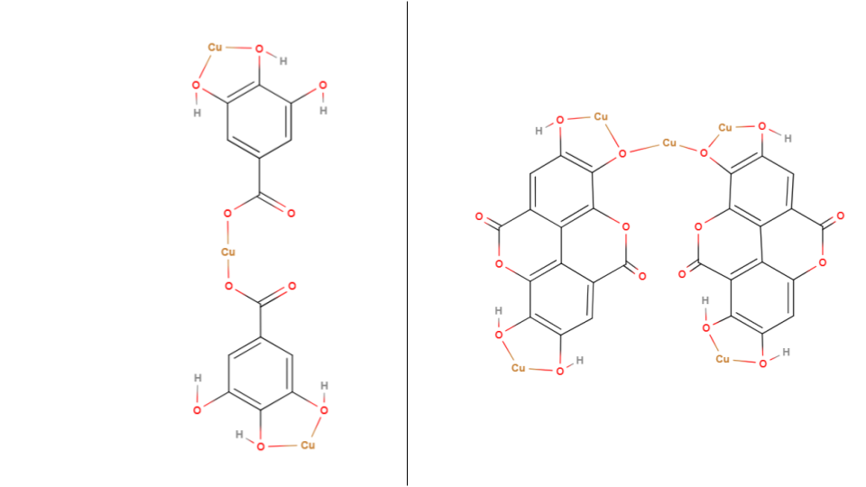

*Figure 15: Plausible Cu-GA complex (left) that may form in pH 5 and 7 and a plausible Cu-EA complex (right) that may form in pH 7.*

# 12 Conclusion

This investigation elucidates the potent chelating prowess of the phenolic acid derivatives extracted from PPP in complexing with aqueous Copper (II) ions – namely GA and EA – hence spotlighting a viable, environmentally friendly method for treating heavy metal contaminated water. Furthermore, the study has set boundaries for maximal EI through exploring solvent-mediated extraction, mass of PPP used, the optimal metal ion to ligand ratio as well as the pH environment. The findings thus illuminate a pathway for fostering a 'green chemistry' approach to water remediation through the use of PPs.

# 13 Evaluation

|  |
| --- |
| 13.1 Strengths |
| * The study leverages organic waste products (PPs) for water filtration; hence the side-effects of synthetic alternatives such as EDTA are avoided (Section 2). * Granulation of PPs results in an increase in its surface area - this technique being chosen in order to maximize the efficiency of ligand extraction and allow for greater penetration of the plant matrix. * The study establishes PPP as a reservoir of GA and EA which are possible remediating agents (Section 4.5). * Using a UV-Visible spectrophotometer ensures a high degree of reliability in the measurements of the degree of interaction between the metal and ligand solution. * The utilization of a spectrum of readily available organic solvents ensures low economic costs while achieving a high EI. * Through exploring a wide array of complexation conditions, the study has effectively asserted PPP as an effective and viable green alternative for the treatment of copper (II) ions in water. * The analyses were substantiated with sound reasoning, even in instances where the data did not align with the hypotheses. |
| *Table 24: Strengths of study* |

|  |
| --- |
| 13.2 Limitations |
| * The study establishes methanol as the most performant solvent for the extraction of ligands from PPs (Section 11.1). However, it is known for its toxic and volatile nature (Medina), which complicates its usage in heavy-metal contaminated water treatment in industrial settings. * A larger pH range inclusive of alkaline environments were not tested – although a higher EI was expected in those ranges (Section 4.8) – due to the high expected levels of copper precipitation (Section 4.8) which would have negatively affected the measured EI. * Authentic heavy-metal polluted water samples were not utilized in this study, potentially indicating that the observed results could differ in real-world scenarios. |
| *Table 25: Strengths of study* |

|  |  |
| --- | --- |
| 13.3 Weaknesses | |
| Systematic Errors | Random Errors |
| * The ligand extraction solution may have contained competing polyphenols which could not be eliminated, possibly hindering the expected results. * Although preventative measures were taken, the decomposition of the PPP in storage would have resulted in the degradation of the polyphenols within the peel (Fawole and Opara), negatively affecting the EI values for later studies. | * The preparation of the analytes was conducted only once, which compromises the general reliability of results. Repetition of the tests would result in increased reliability of results. |
| *Table 26: Weaknesses of study* | |

# 14 Further Scope

The study can be expanded to investigate PPP’s efficacy in scavenging with additional heavy-metal contaminants such as nickel and zinc which are also present in heavy-metal polluted water. Moreover, further studies could incorporate various species of pomegranates (including white pomegranate) in order to determine how differences in their chemical composition and properties could affect the degree of interaction with metal ions. The PPs could have undergone pre-processing (ex. sun-drying or freeze-drying) prior to granulation in order to determine the effects of such processing methods on its water remediation performance.

# 15 References

n.d. 13 February 2024. <https://pubchem.ncbi.nlm.nih.gov/>.

Akagawa, Mitsugu and Kyozo Suyama. "Amine oxidase-like activity of polyphenols: Mechanism and properties." *European Journal of Biochemistry* 268.7 (2008): 1960. March 2024. <https://febs.onlinelibrary.wiley.com/doi/pdf/10.1046/j.1432-1327.2001.02068.x>.

Araya, Magdalena, Manuel Olivares and Fernando Pizarro. "Copper in human health." *International Journal of Environment and Health* 1.4 (2007): 609, 615.

Bala, I., et al. "Analytical methods for assay of ellagic acid and its solubility studies." *Journal of Pharmaceutical and Biomedical Analysis* 40.1 (2006): 209.

Barret, Jack. *Inorganic chemistry in aqueous solution*. Vol. 21. London: Royal Society of Chemistry, 2003. 20 February 2024. <https://books.rsc.org/books/monograph/307/Inorganic-Chemistry-in-Aqueous-Solution>.

Belščak-Cvitanović, Ana, et al. "Overview of polyphenols and their properties." *Polyphenols: Properties, Recovery, and Applications* (2018): 3, 12, 16-18.

Brown, Catrin and Mike Ford. *Higher Level Chemistry 2nd Edition*. 2. Harlow: Pearson Baccalaureate, 2014. Book.

Burke, John. "Part 1 - Solutions and Molecules." *AIC Book and Paper Group Annual* 3 (1984): 13-58. 10 December 2023. <https://cool.culturalheritage.org/byauth/burke/solpar/>.

Chieh, Chung (Peter). *Hydration*. n.d. 16 February 2024. <https://chem.libretexts.org/Bookshelves/Physical_and_Theoretical_Chemistry_Textbook_Maps/Supplemental_Modules_(Physical_and_Theoretical_Chemistry)/Thermodynamics/Energies_and_Potentials/Enthalpy/Hydration>.

Clark, Jim. *COPPER*. July 2015. 12 February 2024. <https://www.chemguide.co.uk/inorganic/transition/copper.html>.

Crisponi, Guido, et al. "Kill or cure: Misuse of chelation therapy for human diseases." *Coordination Chemistry Reviews* 284 (2014): 4.

Daneshfar, Ali, Hassan S. Ghaziaskar and Nasrolah Homayoun. "Solubility of Gallic Acid in Methanol, Ethanol, Water, and Ethyl Acetate." *Journal of Chemical & Engineering Data* 53.2 (2008): 1.

Edinburgh Instruments. *Techniques: Uv-Vis Spectroscopy*. n.d. 21 December 2023. <https://www.edinst.com/in/techniques/uv-vis-spectroscopy/>.

Fawole, Olaniyi Amos and Umezuruike Linus Opara. "Effects of storage temperature and duration on physiological responses of pomegranate fruit." *Industrial Crops and Products* 47 (2013): 301, 303.

Flora, Swaran J.S. and Vidhu Pachauri. "Chelation in Metal Intoxication." *International journal of environmental research and public health* 7.7 (2010): 2.

Görgüç, Ahmet, Esra Gençdağ and Fatih Mehmet Yılmaz. "Industrial Pomegranate Wastes and their Functional Benefits in Novel Food Formulations." *Mediterranean Fruits Bio-wastes: Chemistry, Functionality and Technological Applications* (2022): 721. 1 February 2024. <https://link.springer.com/chapter/10.1007/978-3-030-84436-3_31>.

Hinck, Ferguson and Puhaakka. "Resistance of EDTA and DTPA to Aerobic Biodegradation." *Water Science & Technology* 35.2-3 (1997): 7.

Huguenin, Joris, Sidi Ould Saad Hamady and Patrice Bourson. "Monitoring deprotonation of gallic acid by Raman spectroscopy." *Journal of Raman Spectroscopy* 46.11 (2015): 1063-1065. 2024. <https://analyticalsciencejournals.onlinelibrary.wiley.com/doi/10.1002/jrs.4752>.

Kaderides, Kyriakos, Athanasia M. Goula and Konstantinos G. Adamopoulos. "A process for turning pomegranate peels into a valuable food ingredient using ultrasound-assisted extraction and encapsulation." *Innovative Food Science and Emerging Technologie* 31 (2015): 13. 23 February 2024. <https://www.sciencedirect.com/science/article/abs/pii/S1466856415001617>.

Kupnik, Kaja, et al. "Supercritical Fluid and Conventional Extractions of High Value-Added Compounds from Pomegranate Peels Waste: Production, Quantification and Antimicrobial Activity of Bioactive Constituents." *Plants* 11.7 (2022): 8.

Lancashire, Robert J. *Stability of Metal Complexes and Chelation*. n.d. 6 February 2024. <https://chem.libretexts.org/Bookshelves/Inorganic_Chemistry/Supplemental_Modules_and_Websites_(Inorganic_Chemistry)/Coordination_Chemistry/Complex_Ion_Equilibria/Stability_of_Metal_Complexes_and_Chelation>.

LibreTexts. "Colors of Coordination Complexes." n.d. *LibreTexts Chemistry.* 6 February 2024. <https://chem.libretexts.org/Bookshelves/Inorganic_Chemistry/Supplemental_Modules_and_Websites_%28Inorganic_Chemistry%29/Crystal_Field_Theory/Colors_of_Coordination_Complexes>.

Lucidchart. *Lucidchart*. n.d. 3 December 2023. <https://www.lucidchart.com/pages>.

Manne, Ravi, et al. "Water quality and risk assessment of copper content in drinking water stored in copper container." *Applied Water Science* 12.3 (2022): 3, 5-6.

Medina, Enrique. "Methanol Hazards & Safeguards: Lessons Learned From the Global Supply Chain." *Professional Safety* 59.6 (2014): 67–74. 1 March 2024. <https://onepetro.org/PS/article-abstract/59/06/67/33261/Methanol-Hazards-amp-Safeguards-Lessons-Learned>.

Mo, Yaxian, et al. "Pomegranate Peel as a Source of Bioactive Compounds: A Mini Review on Their Physiological Functions." *Frontiers in Nutrition* 9 (2022): 2-3.

Mokarram, Marzieh, Ali Saber and Vahideh Sheykhi. "Effects of heavy metal contamination on river water quality due to release of industrial effluents." *Journal of Cleaner Production* 277 (2020): 18, 23-24.

MolView. *MolView*. n.d. 2 December 2023. <https://molview.org>.

Muñoz-Muñoz, Jose Luis, et al. "Ellagic acid: Characterization as substrate of polyphenol oxidase." *IUBMB Life* 61.2 (2008): 173-174. 2024. <https://iubmb.onlinelibrary.wiley.com/doi/full/10.1002/iub.143>.

Rashed, Musaab K. and Wissam Tayh. "Removal of Heavy Metals from Wastewater Using Pomegranate Peel." *IOP Conference Series: Materials Science and Engineering* (2020): 1-2.

Rehman, Kanwal, et al. "Prevalence of Exposure of Heavy Metals and Their Impact on Health Consequences." *Journal of Cellular Biochemistry* (2017): 2.

Tran, Erica and Dennis Liu. *Solubility and Factors Affecting Solubility*. 30 January 2023. 2024. <https://chem.libretexts.org/Bookshelves/Physical_and_Theoretical_Chemistry_Textbook_Maps/Supplemental_Modules_(Physical_and_Theoretical_Chemistry)/Equilibria/Solubilty/Solubility_and_Factors_Affecting_Solubility>.

Tsuchida, Ryutaro. "Absorption Spectra of Co-ordination Compounds. I." *Bulletin of the Chemical Society of Japan* 13.5 (1938): 388–400. 10 December 2023. <doi.org/10.1246/bcsj.13.388>.

U.S. Congress, Office of Technology Assessment. *Copper: Technology and Competitiveness*. Office of Technology Assessment, 1988. 16 January 2024. <https://www.princeton.edu/~ota/disk2/1988/8808/8808.PDF>.

United Nations. *Goal 6*. 2022. 17 January 2024. <https://sdgs.un.org/goals/goal6>.

Water.org. *An Economic Crisis*. n.d. 17 January 2024. <https://water.org/our-impact/water-crisis/economic-crisis/>.

Yoder, Claude H. and Natalie J. Flora. "Geochemical applications of the simple salt approximation to the lattice energies of complex materials." *American Mineralogist* 90.2-3 (2005): 492. 20 February 2024. <https://www.degruyter.com/document/doi/10.2138/am.2005.1537/html>.

Zarfeshany, Aida, Sedigheh Asgary and Shaghayegh Haghjoo Javanmard. "Potent health effects of pomegranate." *Advanced Biomedical Research* 3.1 (2014): 1-6.

# 16 Appendix

## 16.1 Uncertainties

### 16.1.1 Varying copper standards

|  |  |
| --- | --- |
| The fractional uncertainty of the concentration of the standards are calculated by:  **c** = metal concentration (moldm3) | **m** = Mr of CuSO4 | **v** = volume of water added  For 0.025 moldm-3:  This calculation is repeated for the other standard concentrations: | |
| 0.05 moldm-3 | ±1.45×10-4 |
| 0.075 moldm-3 | ±1.38×10-4 |